How to find TumbleBooks:

- Click on the button TumbleBooks on Mrs. Raniolo’s website

- Scroll down until you see TumbleBooks icon on the left hand side

- When TumbleBooks opens, search the title of the book you are looking for.

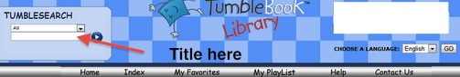

- Click on “Read Online” and Enjoy!

